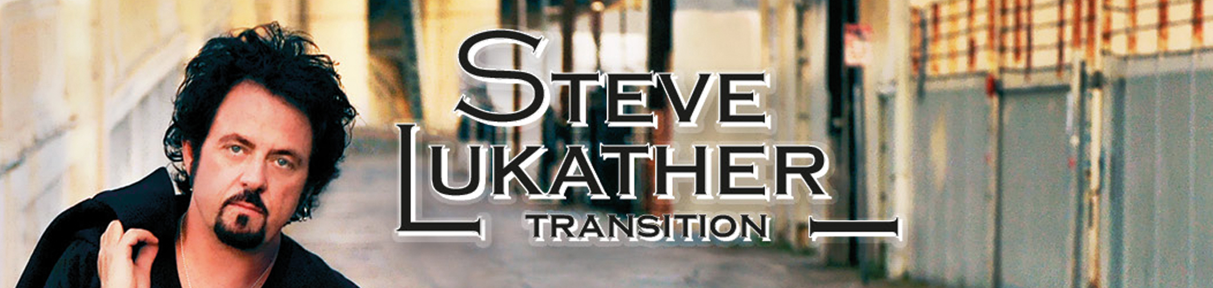
Steve Lukather’s new album Transition on Mascot Records strikes a perfect balance of style, power and imagination as he takes risks and challenges himself in ways most other players can’t even approach.

That’s been standard operating procedure for this high-wire artist of the six-string for nearly four decades, as his career has gone from the studios of Los Angeles to the world’s biggest concert halls to the helm of the multi-platinum selling group Toto and, recently, to ground-breaking tours with Ringo Starr, guitar geniuses Joe Satriani and Steve Vai, and the reunited Toto, who have scheduled a follow-up 35th anniversary tour for 2013.

“I’ve got a lot to be thankful for, and now is a perfect time for me to take stock of that, which is part of what Transition is about,” Lukather says.

Over the previous decade a series of trials including divorce, the death of his mother and business hassles had dampened his joy in music making — a passion that drove Lukather to excel since seeing the Beatles on the Ed Sullivan as a seven-year-old growing up in San Fernando Valley. But today the guitar guru is happy, healthy and strongly reconnected to his muse, and the lushly expressive Transition, his second Mascot album, finds him at a creative pinnacle.

“I equate recordings to paintings,” he explains, “ and I wanted to make Transition a big, beautiful album with lots of fine details and shadings and colors. That’s what I do and what my favorite albums — Sgt. Pepper’s, Dark Side of the Moon, Electric Ladyland, Goodbye Yellow Brick Road — are all about. So if it’s a sin to make massive sounding records with huge production values, then I’m going to Hell.”

Fat chance, because Transition’s heavenly sonic architecture — erected with the help of such A-list musical friends as Def Leppard’s Phil Collen, superstar bassists Lee Sklar, Nathan East, John Pierce, and Tal Wilkenfeld, live band members Steve Weingart, Renee Jones, and Eric Valentine, along with mega-drummers Gregg Bissonette, Chad Smith of the Red Hot Chili Peppers, Tos Panos, and Lukather’s longtime keyboard foil and co-writer / co-producer C.J. Vanston — actually weaves a tale of redemption.

Beginning with the snarling rhythmic heartbeat of the cutting “Judgment Day” and the evil kiss-off blues “Creep Motel,” the album builds to the pivotal title track.

“‘Transition’ is a turning point for the album and a turning point for me,” Lukather explains. “As we were writing the songs, I was thinking about everything I’ve seen — all the people I’ve lost in my life, the great and the difficult experiences I’ve had, and how ultimately it was time to get it together and embrace things for what they are, because we’ve only got one life to live and we’ve got to make the most of it.”

Despite the album’s harmonic depth and sonic surprises, Lukather explains that he kept his guitar sound organic. “These days I like it simple and direct,” he says. “I plugged my new Music Man L-3 signature model guitar straight into a Bogner amp and miked it with an SM-57. Any effects were added at the mixing desk. I used a Kemper Profiling Amp for some of the weird sounds, and that was it. Live these days it’s just my guitar and amp and a couple stomp boxes — and I just go for it.”

“I’ve been working really hard on my vocals,” Lukather attests. “For me, these days it’s all about the song and the performance. I’m not interested in being the fastest gun in the West. I want to make beautiful music that means something.”

Lukather, Weingart and Vanston’s closing instrumental rendition of the Charlie Chaplin classic “Smile” has a very deep connection for the guitarist. “That was my mother’s favorite song,” he relates. “We’ve been playing it as an encore live, and it seemed like the perfect way to close the album, too.”

Transition was recorded over a 10-month period during breaks in Lukather’s juggernaut 2012 touring schedule, which included dates with Deep Purple’s Ian Gillan, the reunited Toto, the guitar-riffic G3 tour with Satriani and Vai, and Ringo Starr.

“Honestly, playing with Ringo and Joe Satriani and Steve Vai, and my high school friends in Toto helped make this the best year of my life,” he says. Lukather notes — getting the call from Ringo was a childhood fantasy realized. “I play music because of the Beatles, and to be standing on stage playing a Beatles song while I look back at the drum kit and see Ringo… unbelievable! He’s such a wise, funny and gracious man.”

Lukather has also worked with George Harrison and Paul McCartney — just part of a historic resume that began when he was in his teens, playing recording sessions in LA and learning about life on the road with Boz Scaggs after Scaggs’ landmark album Silk Degrees.

A five-time Grammy Winner and member of the Musicians Hall of Fame, Lukather has also worked with an A-list of fellow guitar giants: Eddie Van Halen, Robben Ford, Lee Ritenour, Larry Carlton, Slash, Zakk Wylde, Jeff Beck, Eric Clapton, Carlos Santana, and Joe Bonamassa among them. He’s also co-led Toto with fellow founder David Paich through every twist of the band’s platinum lined history while playing on albums by Michael Jackson, Warren Zevon, Aretha Franklin, Stevie Nicks, Don Henley, Miles Davis, Roger Waters, Cheap Trick and other rock and pop royalty. And he’s done all that while writing hits for the Tubes and George Benson, plus maintaining a parallel solo career of his own that began with his 1988 solo debut Lukather.

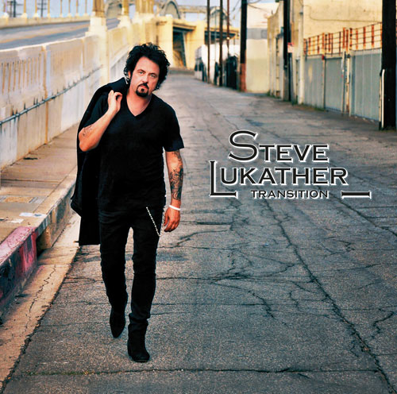
Seven solo albums later, Lukather reflects: “I’d like to say this is the best album I’ve ever made, but that’s a cliché. But I do think I’ve realized my goal of moving forward, so let me say that Transition is possibly the best reflection of who I am in 2012.”
Tracklist:
- Judgement Day
- Creep Motel
- Once Again
- Right The Wrong
- Transition
- Last Man Standing
- Do I Stand Alone
- Rest Of The World
- Smile

